Steam Tutorial

By: Christopher Barclay



**Introduction**

When Steam was in its infancy, it was nothing more than basic game management software. As the years have gone on, Steam has evolved into a massive community where users can have their games and friends interlinked. The four main aspects of steam are the community hub, store, game library, and your profile page. The goal of this tutorial is to show you how to download/install Steam and provide you with a basic understanding of the store and the library. This will provide you with enough knowledge to use Steam at a basic level.

**Prerequisite**: Steam Account. If you do not have a Steam account created already, please head to <https://store.steampowered.com/join/> and be sure to check the confirmation email afterwards.

**Outline**

**Part 1:** Downloading/Installing

1. Download Link (Pg. 2)
2. Installation Guide (Pg. 2)

* *Tips and Warnings*

1. Opening Steam (Pg. 3)
   * *Logging In*

**Part 2:** Using the Store

1. Browsing by category (Pg. 3)
2. Searching by title (Pg. 4)
3. Purchasing a game (Pg. 4)

**Part 3:** Using Your Game Library

1. Layout (Pg. 4-5)
2. Filtering library content (Pg. 5)
3. Launching a game (Pg. 5)
4. Related links (Pg. 6)

**Symbols**

http://icons.iconarchive.com/icons/jonas-rask/danish-royalty-free/32/help-icon.pngHelpful Tip http://icons.iconarchive.com/icons/jonas-rask/danish-royalty-free/32/exclamation-icon.png Warning http://icons.iconarchive.com/icons/jonas-rask/danish-royalty-free/32/lock-icon.png Password Needed http://icons.iconarchive.com/icons/jonas-rask/danish-royalty-free/32/minus-white-icon.png Caution

**Part 4:** Conclusion (Pg. 6)

**PART 1: Downloading/Installing**

This section will walk you through getting Steam downloaded and setup. Anyone who has never downloaded Steam before should refer to the steps below.

1. Download Link

Figure 2 - 1

* + - 1. 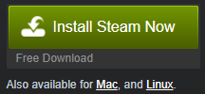Head to <https://store.steampowered.com/about/>
      2. If you are on Windows click Install Steam Now, otherwise click the button for your OS.
      3. After the download has completed you can move onto installing.

1. Installation Guide (Windows Only)

http://icons.iconarchive.com/icons/jonas-rask/danish-royalty-free/32/help-icon.pnghttp://icons.iconarchive.com/icons/jonas-rask/danish-royalty-free/32/exclamation-icon.pngTips and Warnings: Install steam on your OS drive and setup your Steam library on another drive if you are running low on space.

1. Double click the ‘SteamSetup’ executable
2. https://puu.sh/A6Pyd/55bc66469d.pngClick Next
3. https://puu.sh/A6Pyd/55bc66469d.pnghttps://puu.sh/A6Pyd/55bc66469d.pngRead the License Agreement and check the agreement box, click Next https://puu.sh/A6PzJ/054cb69783.png
4. Select your language and click Next
5. Select where you would like to install the Steam Client

https://puu.sh/A6POv/f20c8397fa.pnghttps://puu.sh/A6PCs/416b762a71.png

1. Click Install and let the Steam Installer Finish
2. Opening Steam

http://icons.iconarchive.com/icons/jonas-rask/danish-royalty-free/32/lock-icon.pngLogging In: During this section you will need to login to your steam account which you should have already created.

1. Once Steam finishes installing you can launch the executable.
2. You will be greeted with a login screen where you need to input your Account name and Password. Then you can click the login button

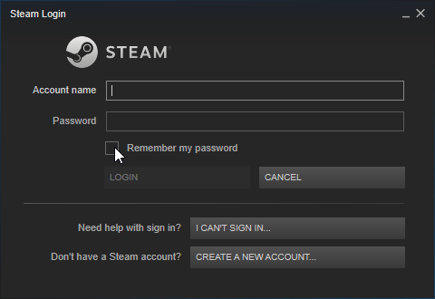

Figure 3 - 1

1. Upon successful login, you will arrive at the Steam store page, which is what the next part of the tutorial covers.

**PART 2: Using the Store**

This section will walk you through using and navigating the Steam store to find and purchase games. Anyone who has never used the Steam store should refer to the steps below.

1. Browsing by category

Figure 3 - 3

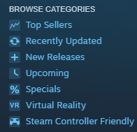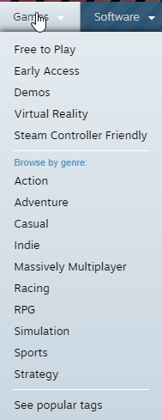In Steam you can browse the store by categories that are recommended or selected on the tags page. To view a quick selection of categories look on the left hand side of the store page (3–2). To view genres hover over Games tab at the top of the store page (3–3). You can also see tags by clicking the button under that same area (3-3).

Figure 3 - 2

1. Searching by title

At the top right of the store page you will see a search bar. You can enter the title or anything closely related to a game to find results.

https://puu.sh/A6RG4/320b71c353.png

Figure 4 - 1

1. Purchasing and installing a game

Figure 4 - 2

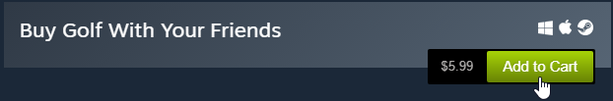Once you are on the store page for the game you wish to install, you will see an area that looks like this.

1. If the game is free then clicking the green button will add the game to your library, otherwise click Add to Cart.

Figure 4 - 3

1. 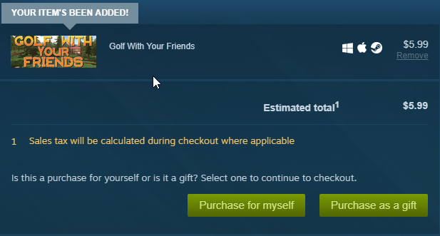You will be redirected to your cart where you can finalize the purchase.
2. Click the appropriate button to finish the purchase
3. The game will then be added to your library which you can learn about in the next section.

**PART 3: Using Your Game Library**

This section will walk you through using and navigating your game library to install, play, and find resources for games. If you haven’t used Steam before, refer to the steps below.

1. Layout

To navigate to your library simply click the Library button on the top left menu bar.

https://puu.sh/A6Oxq/f09fec84ba.png

Figure 4 - 4

The Library has three main sections

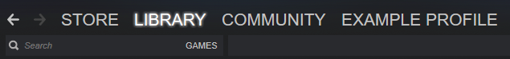Navigation bar and search bar for the library

Figure 5 - 1

Figure 5 - 2

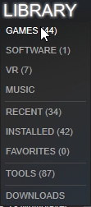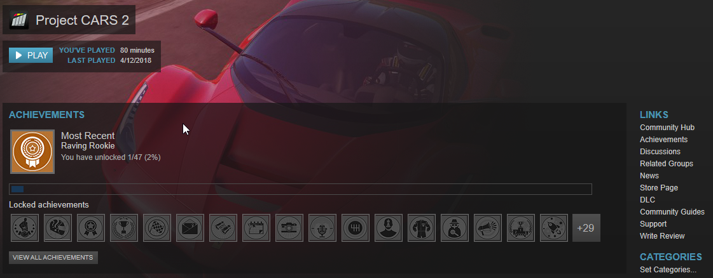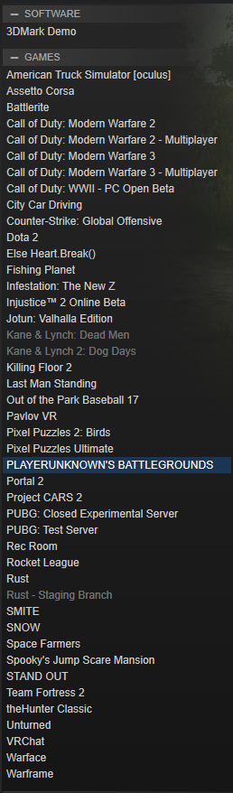The left side of the page will be a stacked list of your game collection (5-1). If you click on a game it will to you to a page similar to the above (5-2).

1. Filtering library content
2. Hover over the Library text on the menu (4-4).
3. Here you can choose to view a certain

portion of your games by filter (5-3).

Figure 5 - 3

1. Launching a game
2. Click on the game you wish to play in the navigation bar. You will be taken to a page similar to the above game. (5-1)
3. https://puu.sh/A6O1g/035c416767.pngIf you have not installed the game yet you will see an install button instead of a Play button. Click this and you will see at the bottom it is installing.
4. 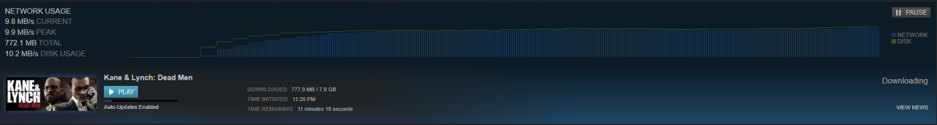If the game is installing you can view its progress at the download page by clicking the DOWNLOADING text in the area shown above.
5. 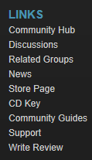Related links

On the right side of any game page in your library there is a group of links. These can take you to all the community and store pages related to the game.

**PART 4: Conclusion**

After following along with this tutorial, you should have the necessary skills to navigate and use Steam’s basic features. I would recommend taking a look around your profile and the community hub to get a feel for what they can offer and following a tutorial on those if necessary. Thank you, Chris.